Baker - 23'8"X38 - 899 SF
2 Bedroom 1 Bath

“Smith Custom Homes of Western Pennsylvania"
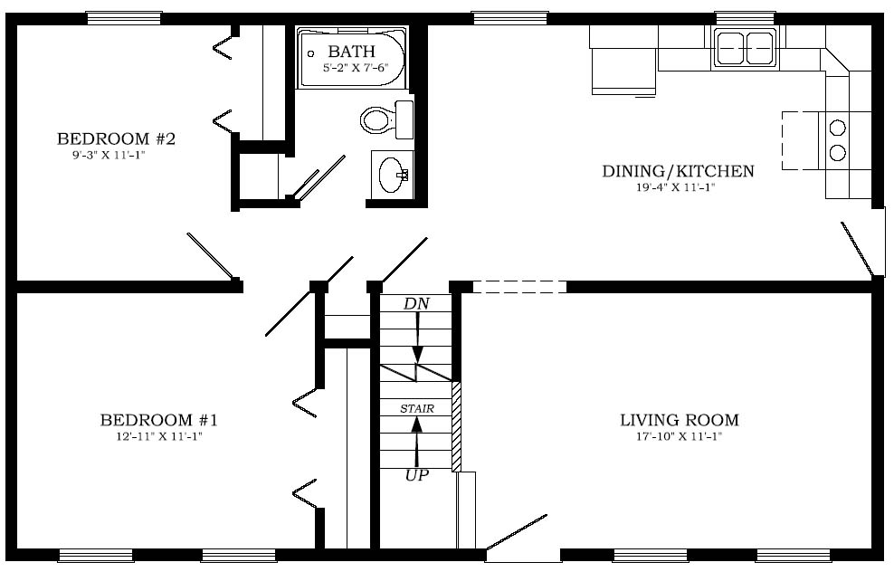

1-800-464-3333

