Brackenridge - 27'6"X32 - 880 SF
2 Bedroom 1 Bath

“Smith Custom Homes of Western Pennsylvania"
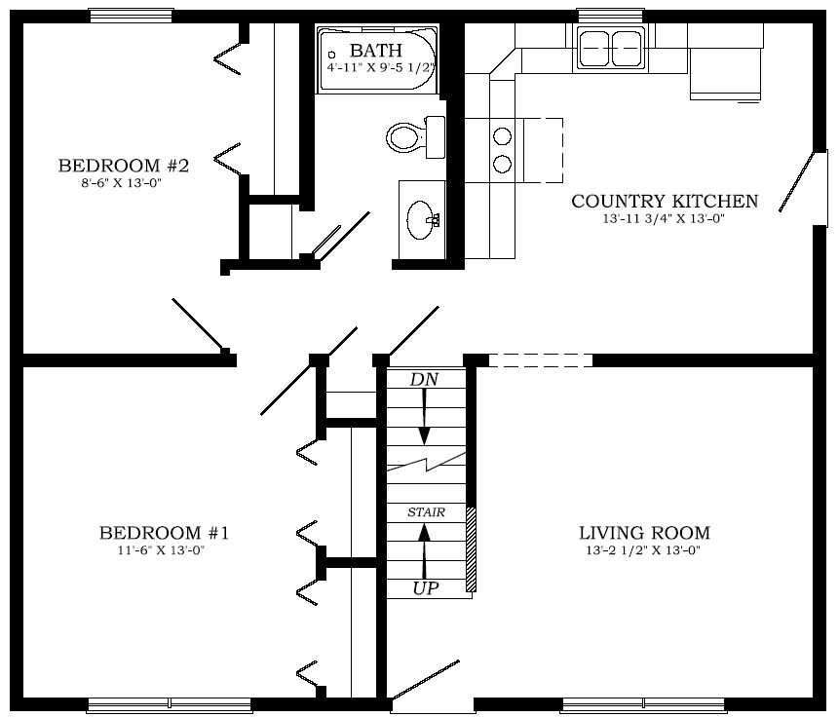

1-800-464-3333

