Dillon I - 27'6"X40 - 1,100 SF
1 Bedroom 1½ Bath

“Smith Custom Homes of Western Pennsylvania"
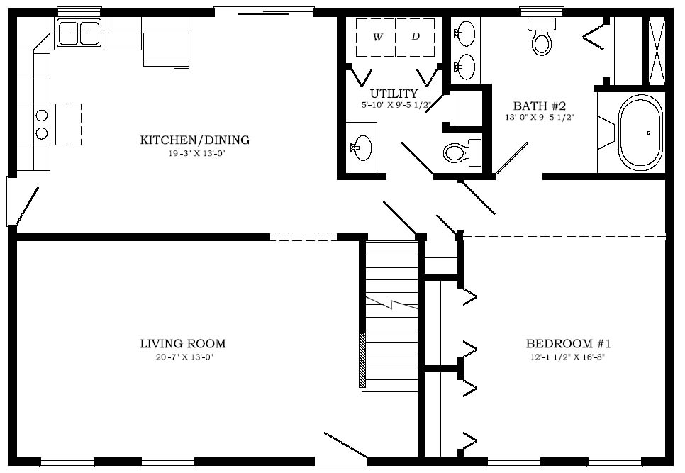

1-800-464-3333

