Elkridge - 23'8"X40 - 1,953 SF
1 Bedroom 1 Bath

“Smith Custom Homes of Western Pennsylvania"
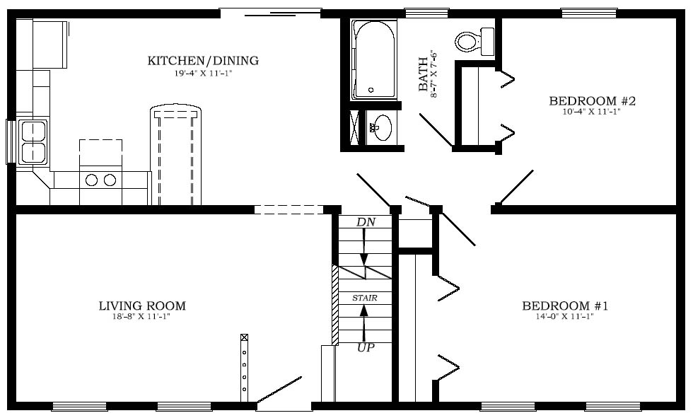

1-800-464-3333

