Lucinda - 27'6"X44 - 1,210 SF
2 Bedroom 1¾ Bath

“Smith Custom Homes of Western Pennsylvania"
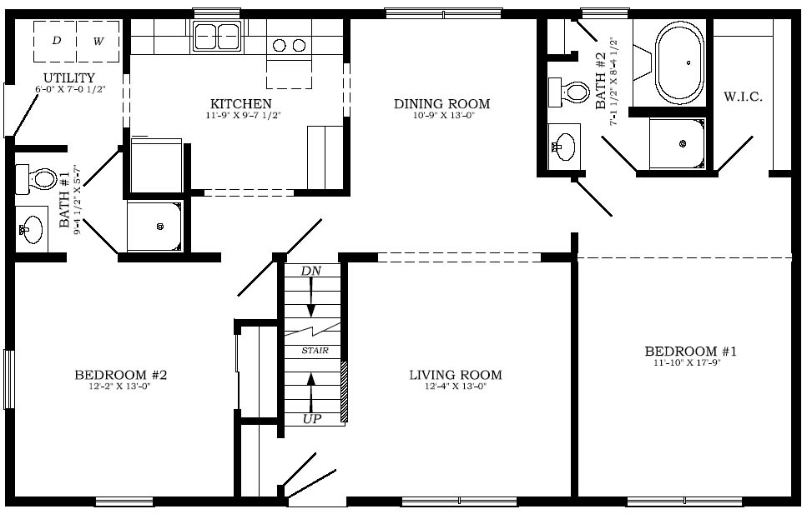

1-800-464-3333

