Northridge - 27'6"X42 - 1,155 SF
1 Bedroom 1 Bath

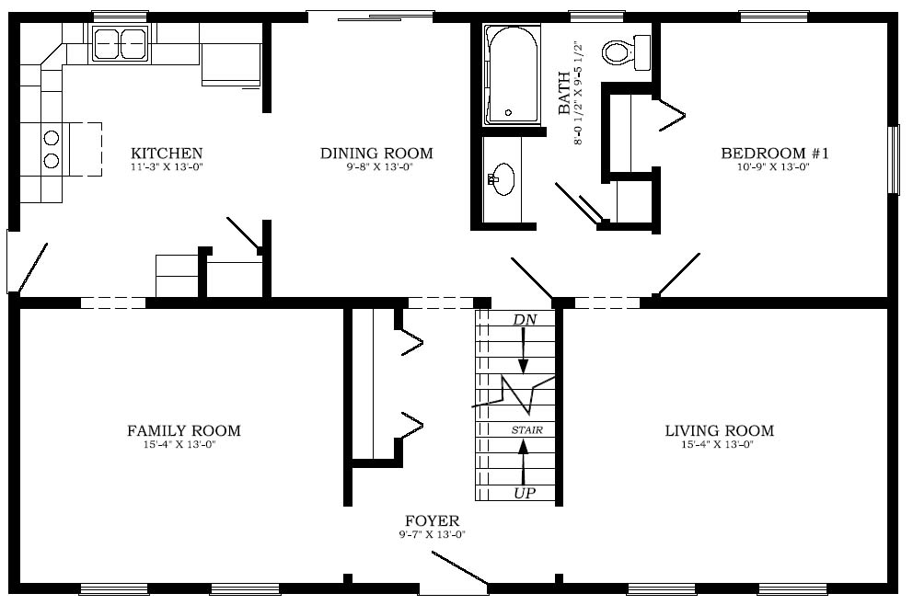
“Smith Custom Homes of Western Pennsylvania"

1-800-464-3333

