Northwood - 27'6"X52 - 1,430 SF
2 Bedroom 2 Bath

“Smith Custom Homes of Western Pennsylvania"
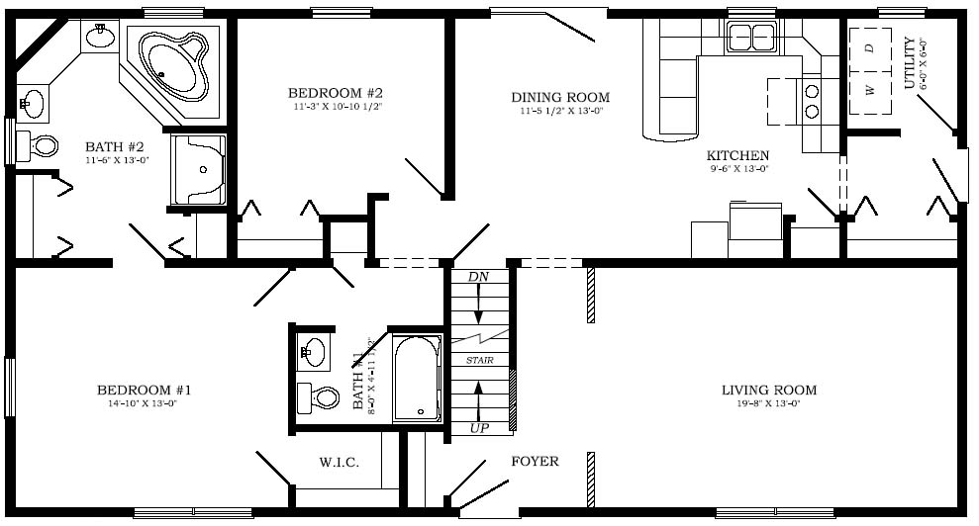

1-800-464-3333

