Seneca Chalet - 23'8"X40 - 946 SF
2 Bedroom 1 Bath

“Smith Custom Homes of Western Pennsylvania"
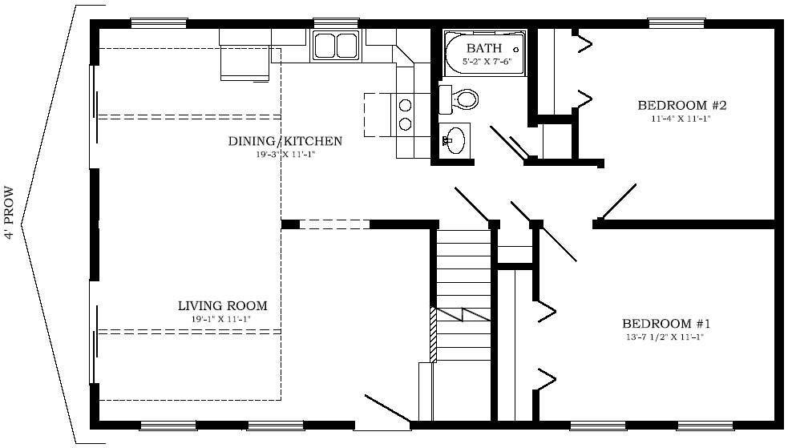

1-800-464-3333

