Buckeye - 27'6"X34/32 - 1,815 SF
3 Bedroom 2 Bath

“Smith Custom Homes of Western Pennsylvania"

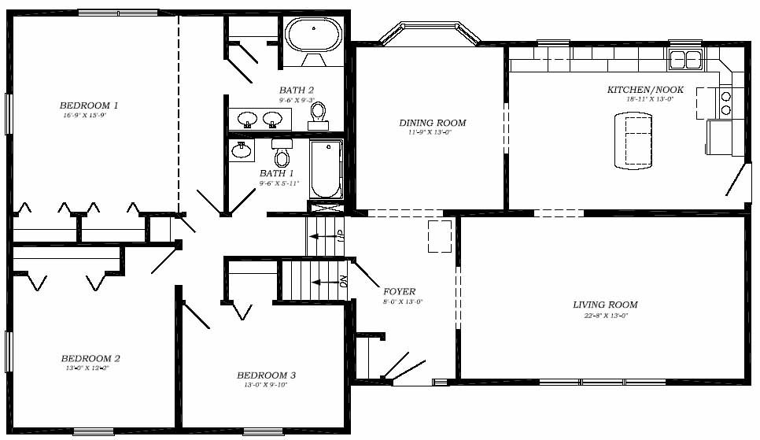

1-800-464-3333

