Butler - 27'6"X48 - 1,320 SF
3 Bedroom 2 Bath

“Smith Custom Homes of Western Pennsylvania"
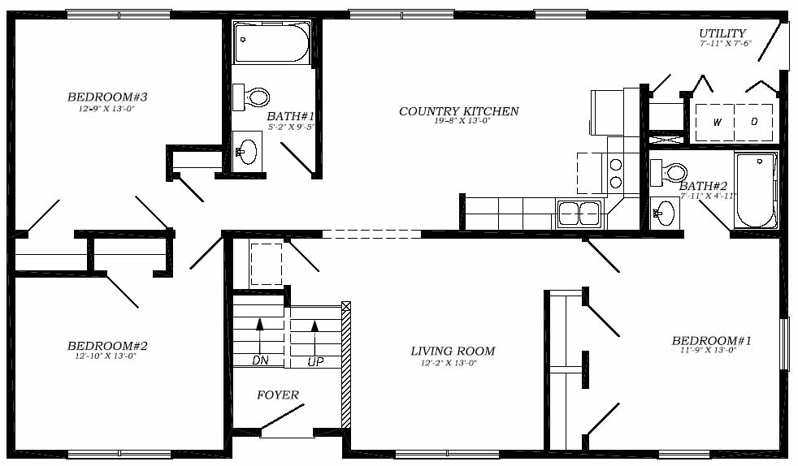

1-800-464-3333

