Georgetown I - 27'6"X44/40/32 - 2,035 SF
3 Bedroom 2 Bath

“Smith Custom Homes of Western Pennsylvania"
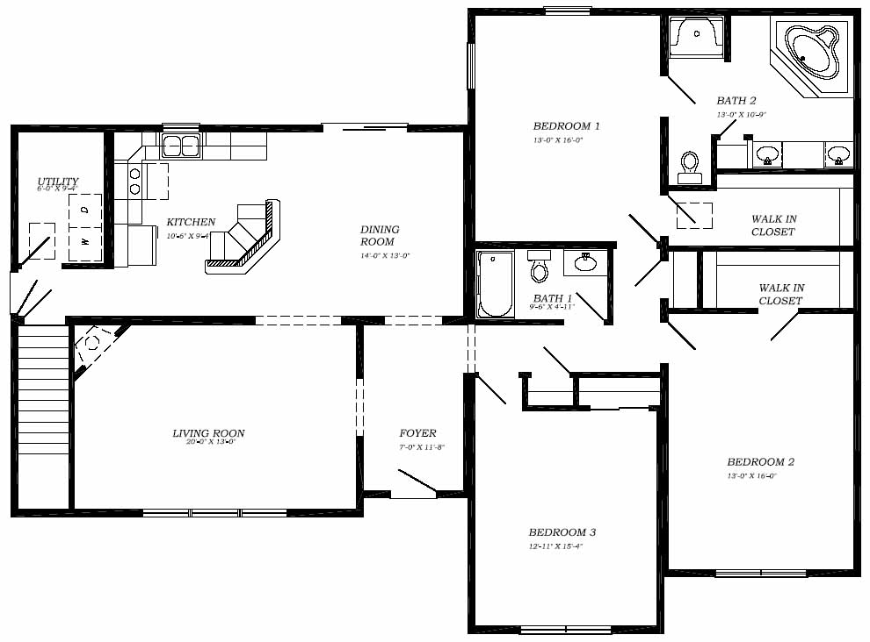

1-800-464-3333

