Amanda - 23'8"X40 - 1,893 SF
3 Bedroom 2½ Bath

“Smith Custom Homes of Western Pennsylvania"
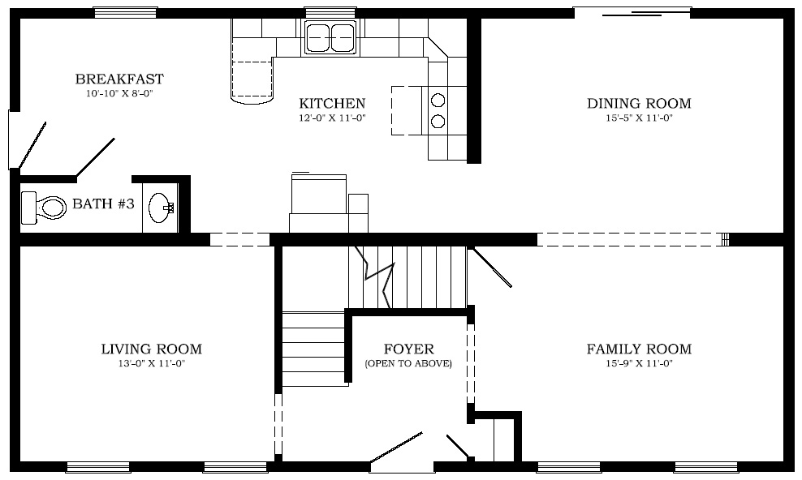

First Floor

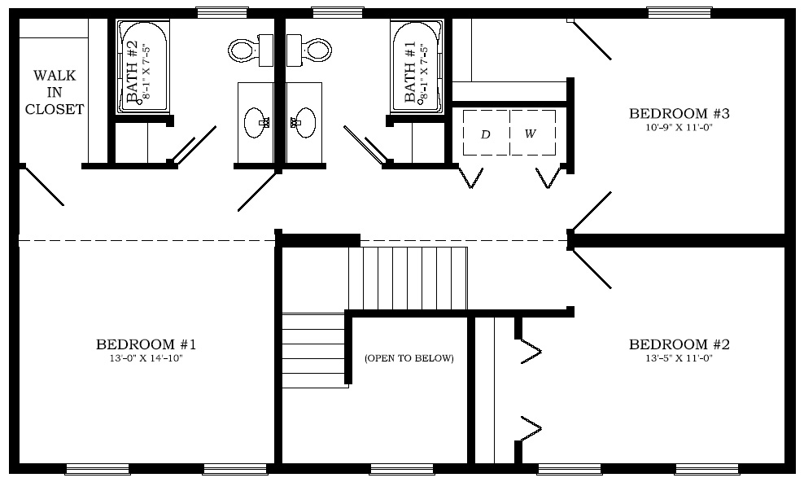

Second Floor

1-800-464-3333

