Edinboro - 27'6"X40 - 2,200 SF
3 Bedroom 1¾ & ½ Bath

“Smith Custom Homes of Western Pennsylvania"
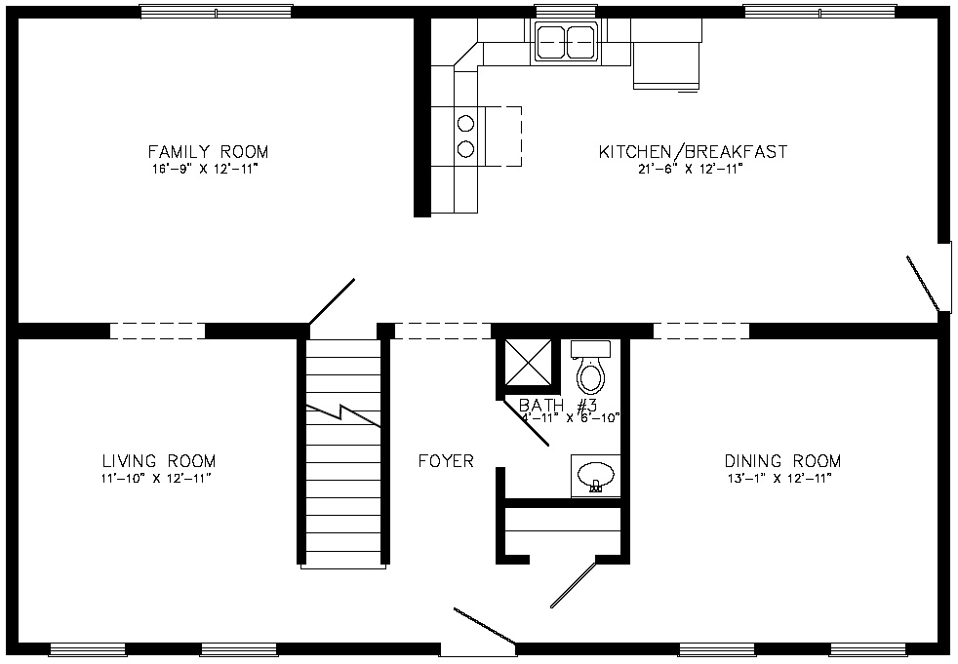

First Floor

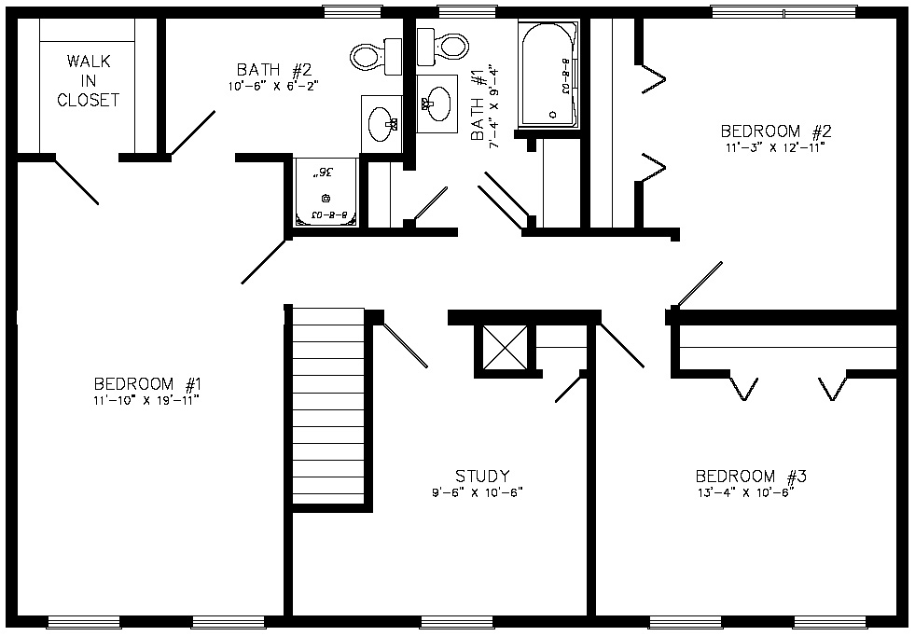

Second Floor

1-800-464-3333

