Hilton - 27'6"X50 - 2,750 SF
3 Bedroom 2½ Bath

“Smith Custom Homes of Western Pennsylvania"
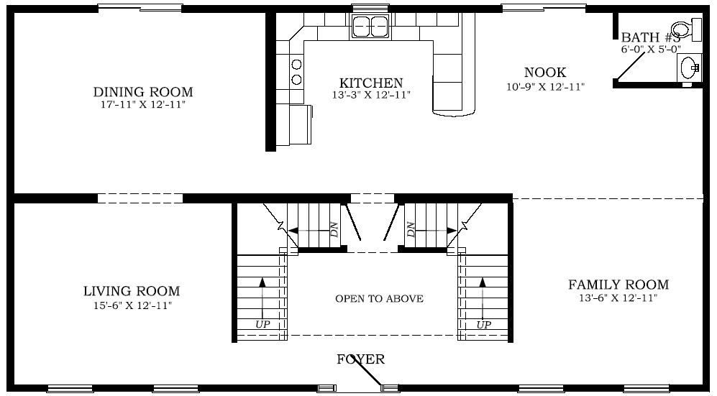

First Floor

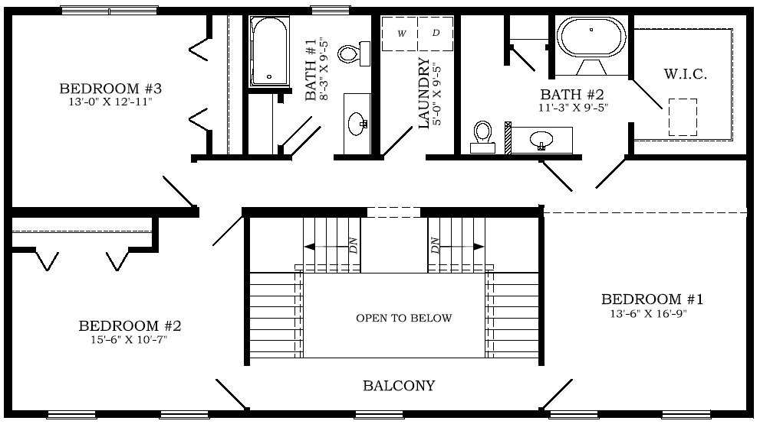

Second Floor

1-800-464-3333

