Oakland - 27'6 X 32/40 - 1,980 SF
3 Bedroom 2 ½ Bath

“Smith Custom Homes of Western Pennsylvania"
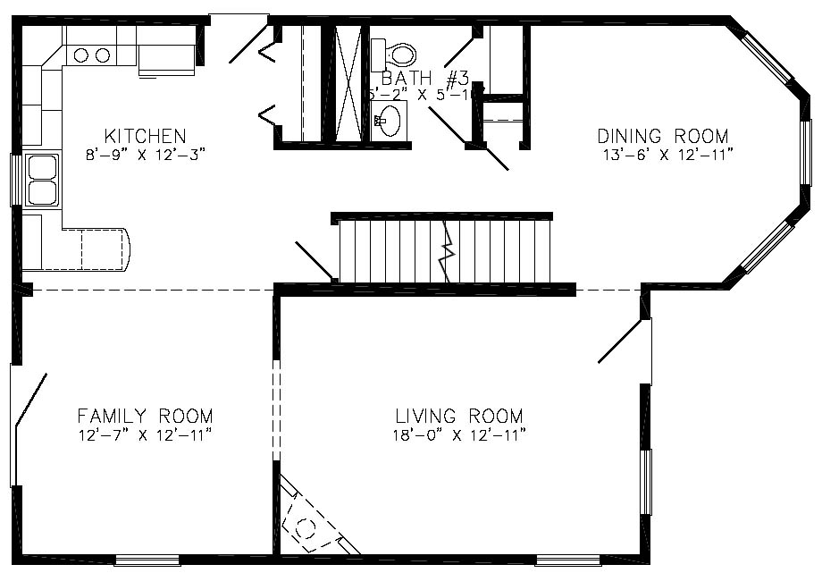

First Floor

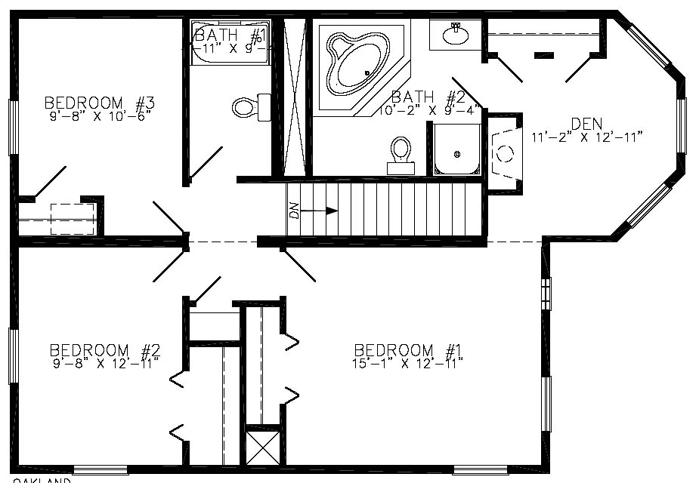

Second Floor

1-800-464-3333

